

*Faith Fun Time: An Interactive Bible Learning Mobile App*

**A PROJECT PROPOSAL FOR CCE 106/L APPLICATION DEVELOPMENT AND EMERGING TECHNOLOGY**

**SUBMITTED TO:**

**MS. CARLA JEAN ZOZOBRADO**

**SUBMITTED BY:**

**CAIN, JOVEN**

**DELAN, ROCHELLE GRACE**

**DIONALDO, ZAMRA ZAMIERRE**

**GOMEZ, JERICHO**

**HERMOSORA, HERA SHEBA**

**INSO, SHEENA MAY**

**PAQUERA, PEARL ANN**

**SEPTEMBER 2025**

**Table of Contents**

**Page**

**CHAPTER 1**

**INTRODUCTION**

Project Context 3

Statement of the Problem 4

Objectives 5

General Objectives

Specific Objectives

Scope and Limitations 5

**CHAPTER 2**

**SYSTEM DESIGN**

Prototype 7

System Diagrams:

UML Class Diagram 12

Use Case Diagram 13

Context Diagram 14

ERD (Entity Relationship Diagram) 15

Flowchart 16

**CHAPTER 3**

**SYSTEM REQUIREMENTS**

Functional Requirements 17

Non-Functional Requirements

Software Testing Plan (UAT)

References

# CHAPTER 1

# INTRODUCTION

# Project Context

Many learners today, especially children and young adults, are drawn more to digital and interactive platforms than to printed devotionals or lengthy Bible lessons. Studies highlight that game-based learning and interactive media can significantly increase motivation and improve retention of lessons (Papastergiou, 2009; Agrawal et al., 2023). This shift in preference underscores the need to explore digital solutions for Bible learning that are not only accessible but also engaging. Thus, this study aims to address the growing demand for a more interactive and meaningful way of engaging with Scripture through a mobile application.

Internationally, the Bible App for Kids has shown how animated Bible stories can reach wide audiences and encourage consistent use. In 2020, it recorded strong global engagement, proving that combining storytelling with interactive visuals resonates well with young learners (Premier NexGen, 2020). This success illustrates the potential of digital platforms in making Bible lessons more appealing to children.

In the national setting, the Philippine Bible Society developed BibliApp Pilipinas, offering multiple translations, reading guides, and audio features (Philippine Bible Society, 2020). While accessible, it remains mostly text- and audio-based, falling short of the interactive and gamified features that today’s learners expect.

Locally, apps like Magandang Balita Biblia provide offline access, daily verses, and simple quizzes. Despite useful updates in 2020, they remain mostly text-based with limited interactive features (Magandang Balita Biblia, 2020).

To fill these gaps, the proposed Faith Fun Time: An Interactive Bible Learning Mobile App will combine stories, gamified quizzes, inspirational content, and family challenges. With progress tracking, achievements, and mobile accessibility, it seeks to make Bible learning inclusive, engaging, and practical for everyday life.

# Statement of the Problem

Even though numerous Bibles and study guides are available, many children and youth often lose interest in using them because the materials are not interactive. Studies show that digital and game-based learning significantly increase motivation and engagement compared to traditional materials (Manuputty, Utami, & Degeng, 2022). Instead, they are drawn to games and applications that are more entertaining but not faith-based.

At present, only a few mobile applications focus on interactive Bible learning, and there is a noticeable lack of engaging features such as games and quizzes that can make learning more enjoyable (Tambunan & Iskandar, 2021). As a result, young users are easily distracted by secular apps, while the potential of technology in supporting Christian education remains underutilized (Simamora, 2022; Lae, 2022). Therefore, there is a need for a mobile application that makes Bible study more fun, engaging, and meaningful for the younger generation.

To address this, the study seeks to answer the following sub-problems:

1. What features can be integrated into the application to make Bible learning interactive and engaging?
2. How can quizzes be designed to enhance learning while maintaining biblical accuracy?
3. In what ways can the application help reduce distractions from other entertainment apps among young users?
4. How can technology be fully utilized to support Christian education through the proposed application?

# Objectives

General Objective

To design and develop Faith Fun Time, a child-friendly Bible learning app with stories, quizzes, and daily verses to make Christian education engaging and meaningful.

Specific Objectives

# To develop a secure login and account system that will:

# allow users to create accounts;

# track user progress and history;

# ensure account security.

# To design engaging Bible stories that will:

# feature animated characters;

# To enable offline accessibility so that users can access stories, verses, and quizzes without an internet connection.

# To allow admin to set up stories, quizzes, and daily quotes, and to enable end-users (children, teens, and adults) to access and interact with the content.

# To develop gamified Bible quizzes that will present questions in a fun, interactive format and will be categorized by Biblical figures and events.

# To provide a 'Verse of the Day' feature that displays daily Bible quotes for inspiration.

# Scope and Limitations

The scope of the project includes several features. These are interactive Bible stories with narration to assist beginners and younger users in following the lessons, gamified quizzes to test comprehension and promote active recall, and a Daily Quotes feature to provide inspirational Bible verses for reflection. A simple and user-friendly interface will be designed to ensure accessibility for children while remaining practical for older users. In addition, the application will include an offline mode that enables access to selected content without the need for constant internet connectivity, which is useful in areas with limited access to the internet.

The project also recognizes its limitations. The interactive stories will only include selected popular Bible narratives and will not cover the entire set of biblical accounts. Certain features, such as daily verse updates and new content, will still require internet connectivity. The first version of the application will be available in English only, which may limit accessibility for users who prefer other languages. Furthermore, the design focuses primarily on individual use, and therefore features for group or community interaction are not included in the initial version.

By defining both its scope and limitations, the project establishes clear expectations for its initial release while creating a foundation for future development. In the long term, Faith Fun Time may expand its coverage by adding more Bible stories, offering multiple language options, and integrating community-based features. This will allow the application to provide a more comprehensive and interactive approach to Bible learning in the digital age.

**CHAPTER 2**

**SYSTEM DESIGN**

**Prototype**

In this prototype, Faith Fun Time: An Interactive Bible Learning Mobile App is designed as a child-friendly platform that provides a safe and enjoyable way for young users to learn and interact. It features a colorful and intuitive interface with large icons and simple navigation, allowing children to explore the app independently. However, while it focuses on stories, quizzes, daily content, and progress tracking, this version serves as a foundation and demonstration of the app’s main functions for further development.

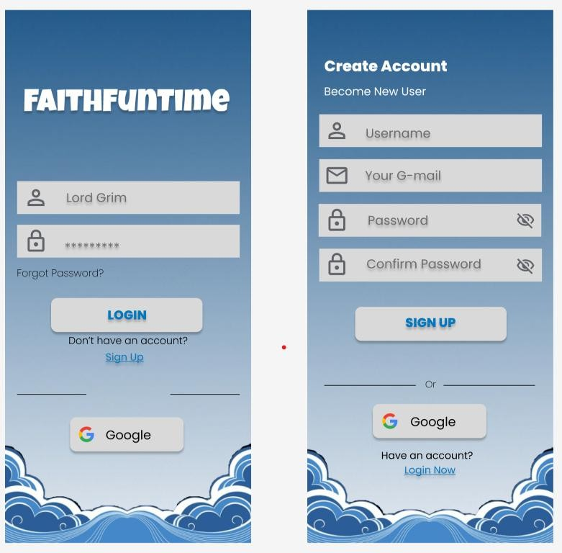

**Figure 2.1** Login Page of Mobile

Figure 2.1 shows the login page of Faith Fun Time mobile application where users can enter their username and password or choose to sign up using email or Google account.

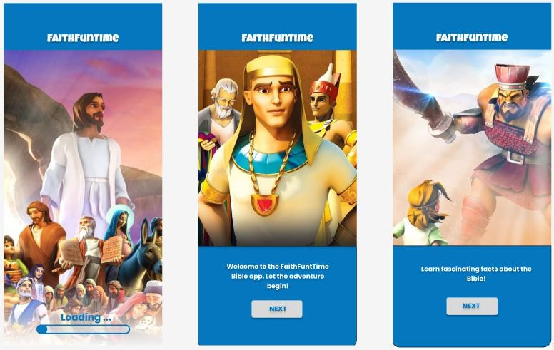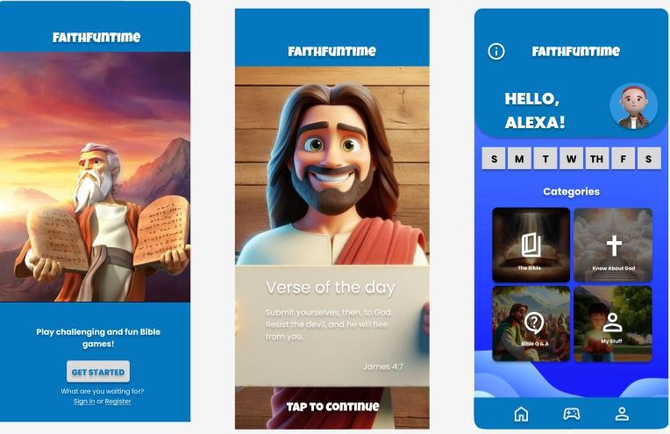

# Figure 2.2 Loading and Dashboard Pages of Mobile

Figure 2.2 shows the loading page and dashboard of the Faith Fun Time mobile application. After logging in or signing up, users are directed to a loading screen, followed by a welcome screen and main dashboard with categories such as The Bible, Know About God, Bible Q&A, and My Stuff.

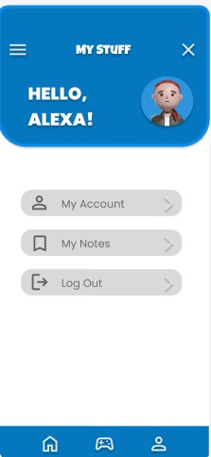

# 

# Figure 2.3 Profile Page of Mobile

Figure 2.3 shows the profile page of the Faith Fun Time mobile application. In this section, users can manage their account by editing details through My Account, reviewing or saving notes in My Notes, and securely logging out of the app.

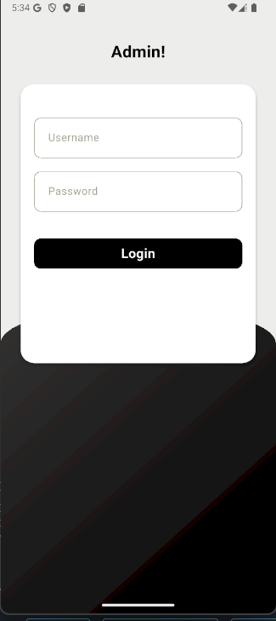

**Figure 3.1.** Admin Login

Figure 3.1 shows the Admin Login interface of the application. It provides input fields for entering a username and password, along with a login button to authenticate the administrator’s credentials. This interface ensures that only authorized administrators can access the system’s backend features and management functions.

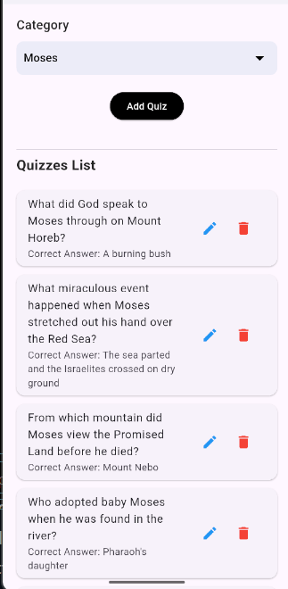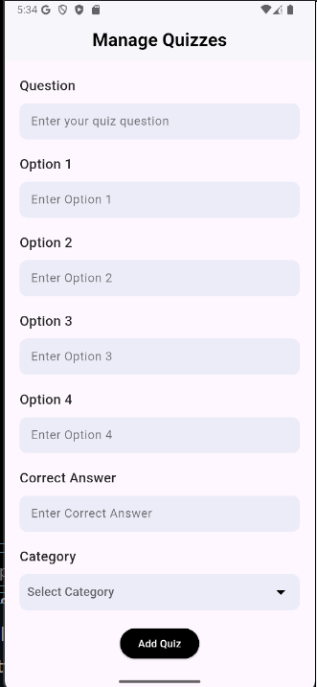

**Figure 3.2.** Manage Quizzes Page

Figure 3.2 shows the Manage Quizzes interface of the application. On the left side, administrators can create new quizzes by entering a question, four possible options, the correct answer, and assigning the quiz to a category. On the right side, the system displays a list of existing quizzes, along with options to edit or delete them. This feature allows efficient management of quiz content to keep the application updated and engaging.

# System Diagrams:

* 1. UML Class Diagram

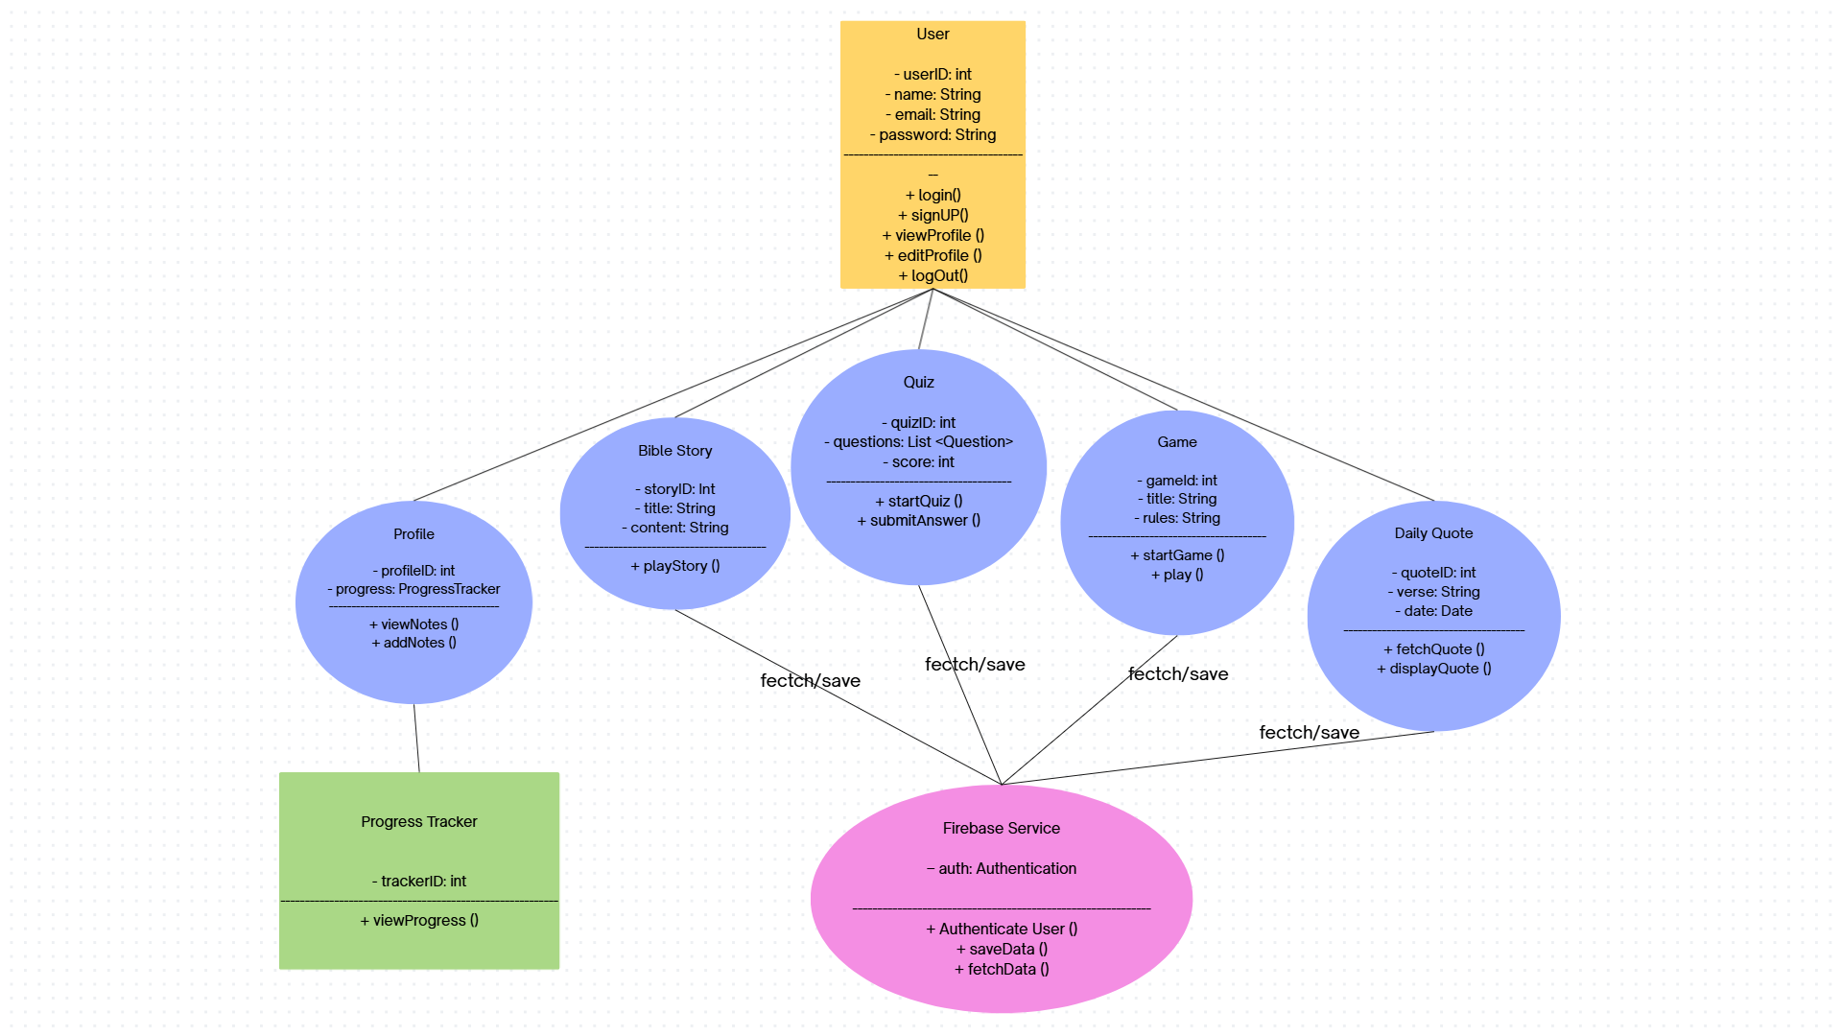

**Figure 3.1** UML Class Diagram of Faith Fun Time Application

Figure 3.1 shows the UML Class Diagram of the Faith Fun Time mobile application. It illustrates the main classes such as User, Profile, Bible Story, Quiz, Game, Daily Quote, Progress Tracker, and Firebase Service. The diagram defines their attributes, methods, and relationships, showing how data is fetched, saved, and managed across different components of the system.

* 1. Use Case Diagram

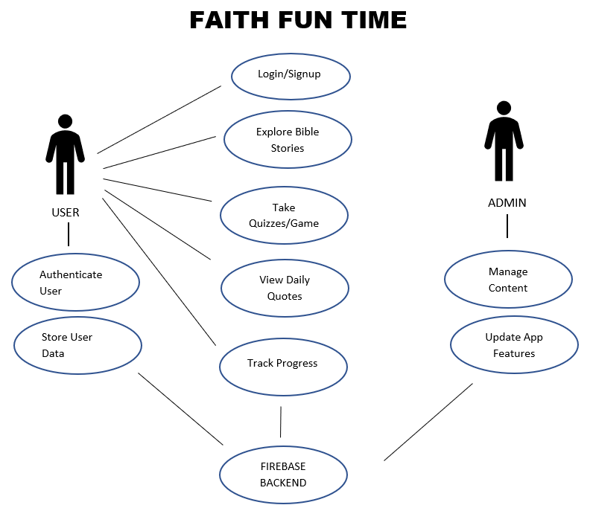

**Figure 3.2** Use Case Diagram of Faith Fun Time Application

Figure 3.2 shows the Use Case Diagram of the Faith Fun Time mobile application. It illustrates the interactions between the User and Admin with the system. The User can perform activities such as login/signup, explore stories, take quizzes or games, view daily quotes, and track progress, while the Admin manages content and updates app features. Both interact with the Firebase backend for authentication and data storage.

* 1. Context Diagram

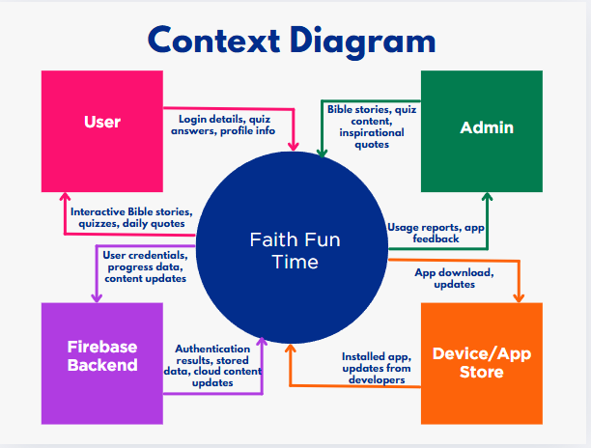

**Figure 3.3** Context Diagram of Faith Fun Time Application

Figure 3.3 shows the Context Diagram of the Faith Fun Time mobile application. It illustrates how the system interacts with external entities such as the User, Admin, Firebase Backend, and Device/App Store. The diagram highlights the flow of information, including login details, user credentials, progress data, content updates, app downloads, feedback, and inspirational content shared between the application and its connected components.

* 1. Entity-Relationship Diagram

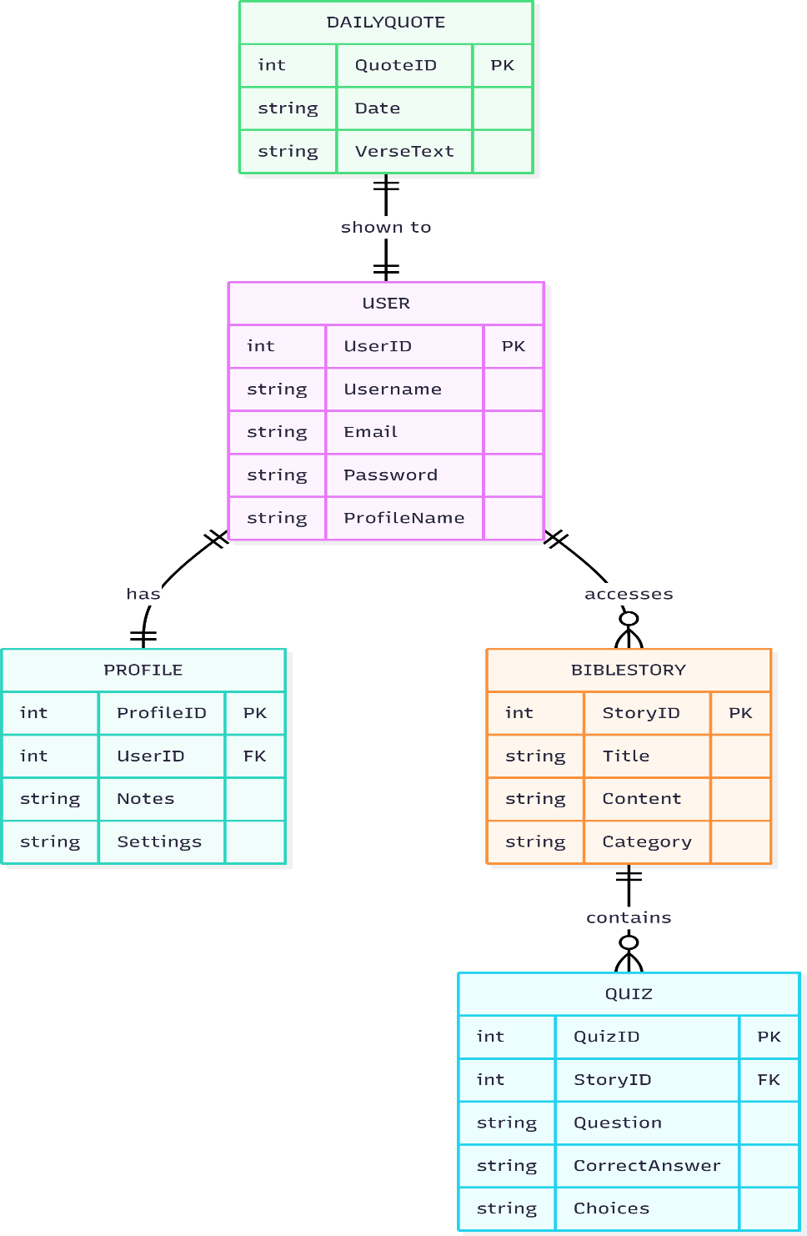

**Figure 3.4** Entity–Relationship Diagram of Faith Fun Time Application

Figure 3.4 shows the Entity–Relationship Diagram (ERD) of the Faith Fun Time mobile application. It illustrates the data entities such as User, Profile, Daily Quote, Bible Story, and Quiz, along with their respective attributes. The diagram also shows the relationships between these entities, including how users manage profiles, access stories, receive daily quotes, and answer quizzes.

* 1. Flowchart

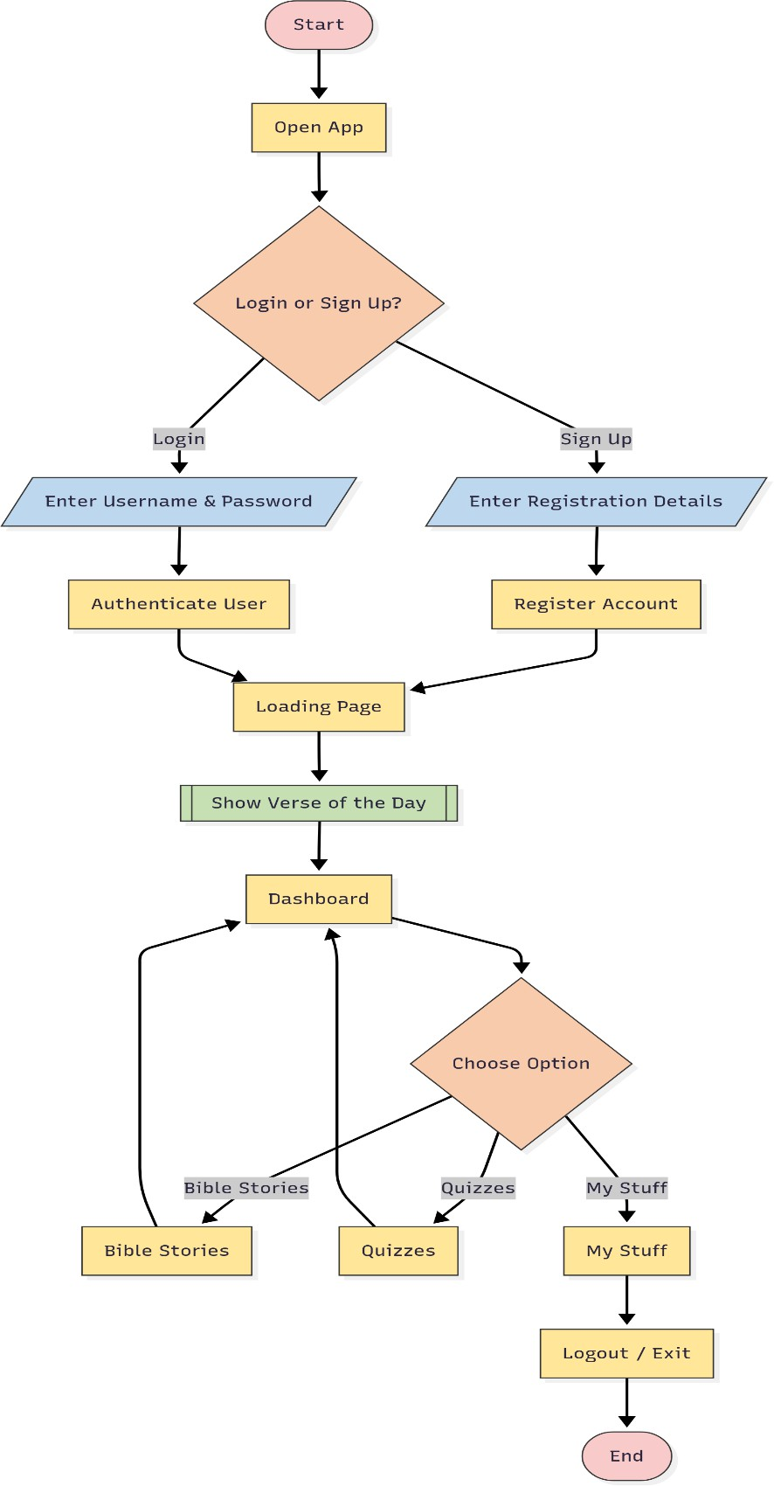

**Figure 3.5** System Flowchart of Faith Fun Time Application

Figure 3.5 presents the system flowchart of the Faith Fun Time mobile application. It depicts the sequence of processes starting from launching the app, user authentication (login or registration), and loading the dashboard. From the dashboard, users can choose different options such as accessing stories, answering quizzes, managing their personal data, or logging out. The diagram highlights the logical flow of actions within the prototype system.

# CHAPTER 3

# SYSTEM REQUIREMENTS

1. **Functional Requirements**

The proposed system, Faith Fun Time: An Interactive Bible Learning Mobile App, will provide the following functions to ensure an engaging and spiritually meaningful user experience:

1. User Registration & Login – Users can create an account using email or Google login. Users can log in securely with their credentials.
2. Dashboard – Displays user profile, categories (Bible, Know About God, Bible Q&A, My Stuff). Shows the Verse of the Day.
3. Interactive Bible Stories – Provides selected Bible stories with narration and visuals. Allows offline access to downloaded stories.
4. Quizzes – Multiple-choice quizzes to reinforce Bible knowledge.
5. Daily Quotes – Delivers inspirational Bible verses daily. Updates automatically with internet connection.
6. Profile Management – Users can view/edit their profile, save notes/reflections, and log out securely.

# Non-Functional Requirements

To ensure usability, reliability, and long-term adaptability, the system will also satisfy the following non-functional requirements:

1. Usability – The application will feature a simple, colorful, and child-friendly interface, while remaining accessible to teens and adults.
2. Performance – The system should load any screen within three (3) seconds. It should support both offline and online access for key features.
3. Security – User credentials will be encrypted. Sessions will automatically log out after a period of inactivity.
4. Portability – The application will be developed in Flutter, making it cross- platform and compatible with both Android and iOS devices.
5. Maintainability – The codebase will be designed for easy updates, allowing developers to add new Bible stories, quizzes, and other features in future versions.

**References**

Islamic lifestyle applications: Meeting the spiritual needs of modern Muslims. (2024, February 3). https://arxiv.org/abs/2402.02061

Lae, Y. H. (2022). Digital transformation and challenges in Christian religious education: A critical perspective. *Didaskalia: Journal of Christian Religious Education, 3*(1), 15–29. https://jurnal.sttii-surabaya.ac.id/index.php/didaskalia/article/view/480

Manuputty, P. L., Utami, D. D., & Degeng, I. N. S. (2022). Systematic literature review: Gamification as a learning approach in Christian religious education in the digital age. *Teknodika, 20*(1), 45–56. https://jurnal.uns.ac.id/Teknodika/article/view/95497

Pratama, A. B., & Azhari, M. F. (2024). Designing a mobile application based on gamification method to increase Muslims’ reading interest. *Khalifa: Journal of Islamic Education, 4*(1), 45–56. https://doi.org/10.24036/kjie

Purwaningsih, E., Nugroho, H., & Supangkat, S. H. (2021). Modifying TAM to understand religious application user acceptance: A study on the eKatolik app. *Ingénierie des Systèmes d’Information, 29*(5), 713–720. https://doi.org/10.18280/isi.290537

Simamora, R. (2022). The impact of media and technology in Christian religious education strategy. *Asian Journal of Philosophy and Religion, 4*(2), 77–86. https://journal.formosapublisher.org/index.php/ajpr/article/view/8774

Tambunan, D. M., & Iskandar, F. (2021). The impact of technology-based learning media on students’ interests in Christian religious education. *Journal of Educational Management and Instruction, 1*(2), 112–120. https://ejournal.uinsaid.ac.id/index.php/jemin/article/view/9628

Umar, I., & Tilli, S. F. (2025). The use of mobile apps for Islamic learning: A study on accessibility and learning outcomes. *Journal of Computers for Science and Mathematics Learning, 2*(1), 6–17. https://doi.org/10.70232/jcsml